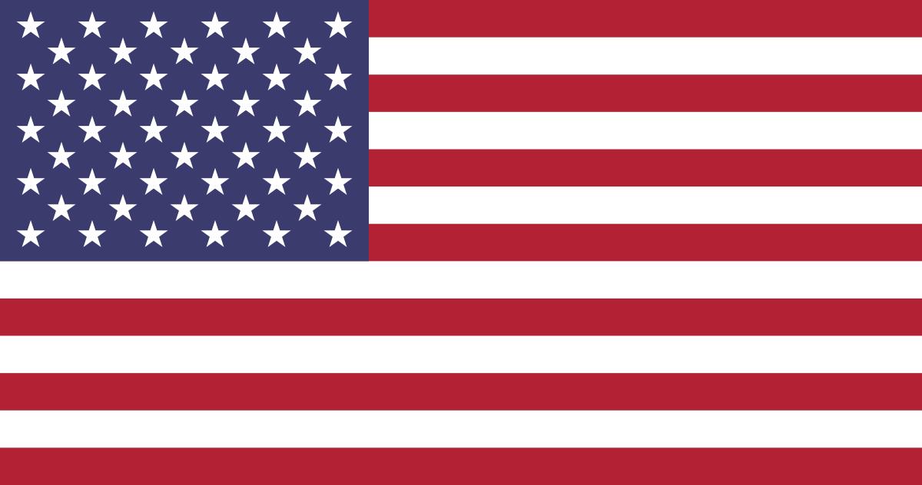
Dance Around the World

USA Factsheet

Question | Answer
What is the USA’s capital city?
What the USA’s currency?
What is the total population of the USA?
Which countries border the USA?
What is the longest river in the USA?
How many states are in the USA?
What is the president of the USA’s name?
Which 4 sports are known as the ‘Big 4’ in the USA?
Can you think of an American sportsperson who has the same name as an animal?
Which are the two main political parties in the USA?
What is the national animal of the USA?
What is the USA’s National anthem called?

