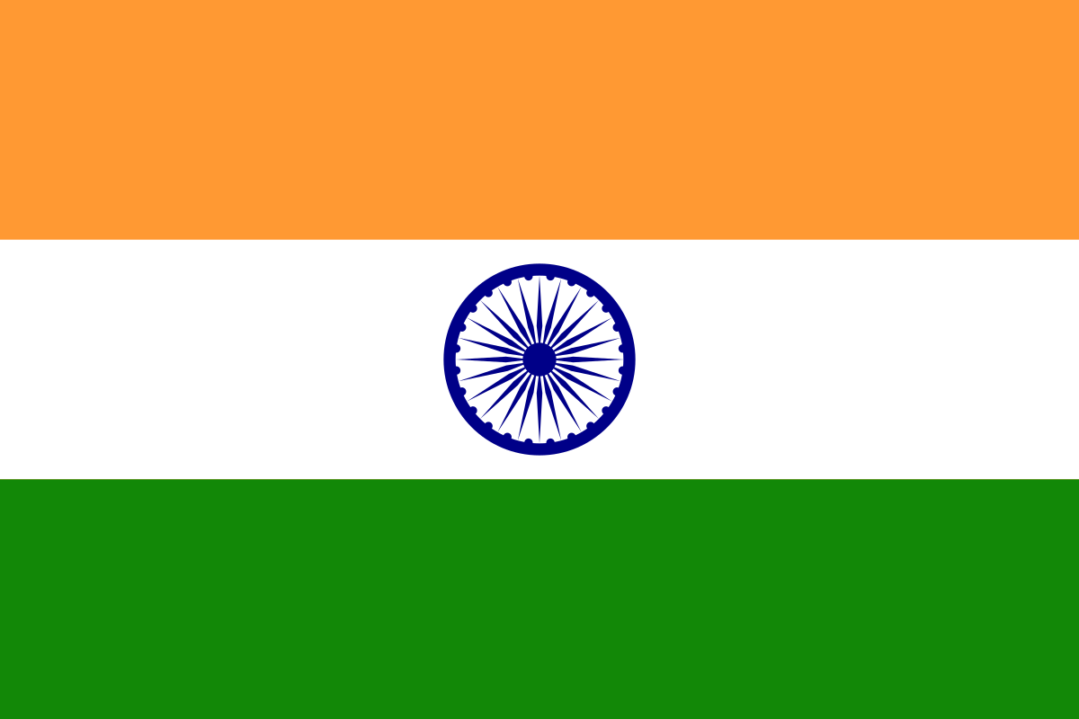
Dance Around the World

India Factsheet

Question | Answer
What is India’s capital city?
What is India’s currency?
What is the total population of India?
Which countries border India?
What is the longest river in India?
What languages are spoken in India?
What is the president of India’s name?
What is the most popular sport in India?
Which player has scored the most test cricket runs for India?
Which religions are in India?

What is the national animal of India?
What is India’s National dance called?

