Panathlon Challenge at Home
Indoor Table Games
Thank you for taking part in the ‘Panathlon at home’ challenges. There are 8 indoor table games in this pack based on Table Cricket & Polybat (side table tennis).
Use these games as a guide. You may adapt the equipment and use whatever objects you’ve got at home. You can change the size of games to fit your space. Challenge yourself. Play for your personal best. Determine to improve on your own records. Involve family members and carers to collaborate and compete against.

Adaptations
Visually impaired players: A helper can clap to aid for direction to a target or assist with changes in direction.
Wheelchair users: Ramps can be used to help propel objects. If you don’t have a ramp, use a long piece of cardboard, change the distances or place the equipment off ground level, for example on a table, instead.
Let us know how well you’ve done via @panathlon on social media and via #PanathlonGardenGames

To receive a certificate please email events@panathlon.com with your score sheet as a record.

Table Polybat - Competitive Game
Video Link - To come, in future update of this document
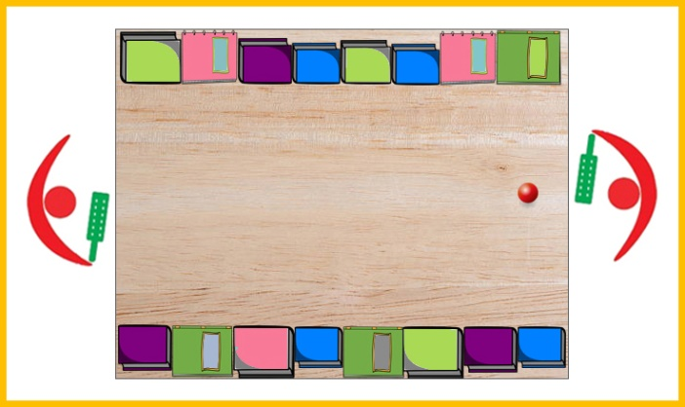
Equipment:
- Table
- Many Books, for sides & 2 x bats
- 1 x Small Light Ball (Air flow, Table Tennis)
- 2 x Chairs
Set up: Clear the table. One chair at each end. Add thick books up each table side with their book spines creating a smooth ‘wall’. Hardbacks will work better. Use 2 layers of books on each side, if needed, to stop the ball bouncing over & off the table.

Aim: “Strike the ball past your opponent.”
- 2 player game. Players are seated throughout.
- Rally starts with a serve. Alternate 2 serves each.
- Strike the ball past your opponent to gain a point, whilst keeping the ball on the surface of the table (small amount of bouncing of the ball is ok).
- The ball can rebound off the books or go straight down the table.
- Note: Players can hit the ball more than once before returning the ball to the opponent ie. a block, then a hit is allowed - providing the ball does not stop.

Scoring:
- Strike the ball past the opponent = 1 point.
- Cause your opponent to commit a foul = 1 point.
- Fouls are:
  - Ball touches a players body, including the hand
  - Ball bounces too high from the surface of the table, including off the sides of the table, over the books
- First to 7 points wins.
- If the score is 6-6, you need to win by 2 clear points, alternate 1 serve each.

Longest Rally - Cooperative Game

Additional Equipment: Kitchen Timer

Aim: “Record the longest rally in 1 minutes play.”
- Collaborative game between 2 players.
- As per Table Polybat rules mentioned above, when a foul is committed, end the rally.

Scoring:
- 1 point for each return hit.
- Longest Rally: Longest unbroken rally in 1 minutes play.
- Total Touches: Total number of hits between the players, during 1 minute, across many rally’s.

Variations:
- Change the rally duration to 30 seconds or 90 seconds.
- Add an obstacle into the middle of the table (tin) to avoid. End the rally if hit.
- Experiment with different balls. Change the size or type. Find a ball that moves slower or faster.
- No Sides Rule: The sides are out-of-bounds, only straight shots.
- Involve more players, for doubles. Can play alternating hits rule, or, alternating every 2 or 3 hits – continuing the rally whilst changing over. May need to stand, rather than sit for this version.
Shooting Gallery - Solo & Cooperative Game

Additional Equipment: 10 x Targets (Paper Cups, Wooden Blocks).
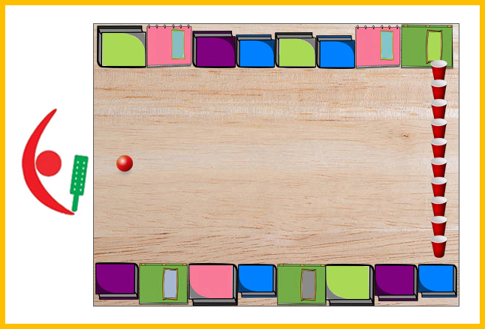
Aim: “Hit the targets from a rebound.”
- Can play on your own or with other players.
- If playing with others in a cooperative game, take alternate turns.
- The targets need to be via a rebound off the sides.
- When a target is hit/knocked over, remove it from the table.
- Straight hits onto the targets are not allowed. If this happens replace the targets back in position.
- Re-place the targets back onto the table only after all 10 targets have been hit.

Scoring:
- 1 point each time the target is hit.
- Timed: How many targets can you hit in 1 minute? You can pause the clock whilst replacing all 10 targets back on to the table.
- Hits: How many strikes do you need to hit all 10 targets on the table? This can also be timed.

Variations:
- To make the game easier allow for both direct hits and rebound hits to the targets.
- Competitive Version: Take alternate turns. First to hit 6 targets wins. Replay if 5-5 draw with one less target for the following game (9 targets).
- Competitive Version: Take 10 shots each. Each player starts with all 10 targets on the table. Highest score wins.
- Penalty Shootout: 1 target. 1 hit each. Continue until one player misses the other hits on the same turn.

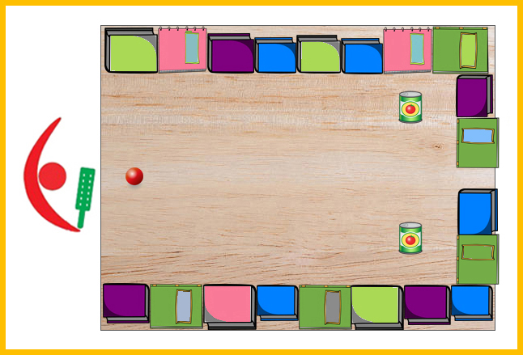
Rebound Relay Variation
Additional Equipment: 2 x Targets (Household item: Tin Can), Books (to add to the end of the table), 2 x Balls
Aim: “Hit the targets from a rebound.”
- Can play on your own, or, with other players.
- Each player has 2 hits per turn.
- Hit 1 ball at a time at the targets via a rebound from the sides. A straight hit onto either target does not score.

Scoring:
- 1 point every time a target is hit.
- Timed: How many times can you hit the target in 1 minute?
- Hits: How many strikes does it take to hit the target 10 times? This can also be timed.
Variations:
- Alternate targets aimed for, left target then right target.
- Change striking position of the ball – centre of table, half-way points between the centre & sides.
- With 2 turns hit each target by only hitting one side of table - requires 2 different angles of shot.
- Competitive Version: Best score after 5 turns each (10 hits in total). Take alternate turns.

Smash & Grab - Solo & Cooperative Game

Additional Equipment:
- 1 x Target (Heavy & Thin, like Full Tin Can)
- 3 or 6 Small Balls (Scrunched up tin foil)
- Kitchen Timer

Set-Up: Place 3 balls close to the end of the table, one at the centre of table, and two at the half-way points between the centre & sides.
Place a target in the centre at the other end of the table. The intention is for the target to stay on the table, even when hit. Add BluTack behind the item, if needed, to keep it in place.

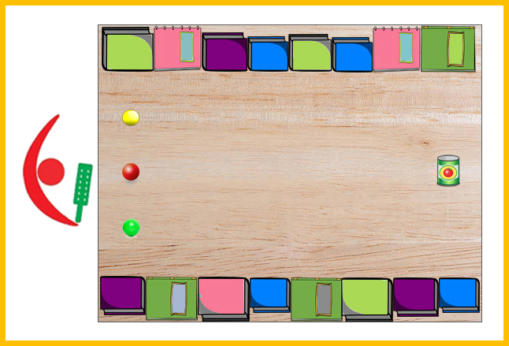
Aim: “Hit the target from all 3 positions. Retrieve the balls.”
- Can play on your own, or, with other players.
- For 1 player, use 3 balls only.
- For more than 1 player, use a maximum of 6 balls.
- Players take 3 strikes per turn, one hit from each position.
- After 3 hits, player collects the balls including any balls which have fallen off the table. If you are playing with others, they can start their go immediately after the last person has played. Continuous relay.

Scoring:
- 1 point, every time the target is hit.
- Timed: How many times can you hit the target in 1 minute?
- Hits: How many strikes do you need to hit the target 15 times? This can also be timed.

Variations:
- To make easier, add extra books across the target end of the table.
- Start with a larger sized item, then progress to a smaller sized item.
- Move the position of the target between rounds.
- Competitive Version: Best score after 3 turns each (9 hits in total). Take alternate turns.
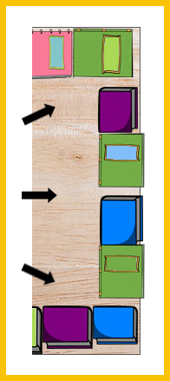
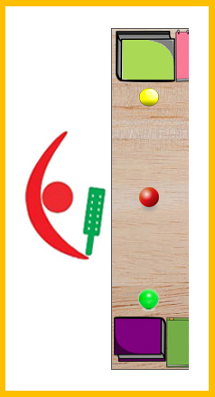
- Move the position of the balls. Pushing them towards the sides of the table makes it more difficult. See image.

- Through The Gaps: Add books across the far end of the table, leaving 1 or 2 gaps. Players aim for the gaps as the ‘Target’, to get the ball through the gaps. See image.

Table Cricket

Video Link - To come, in future update of this document
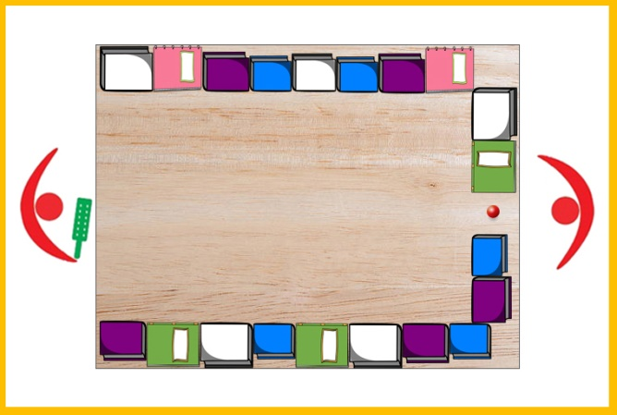
Equipment:
- Table
- Many Books, for sides & 1 x bat
- Many Household Items, like tins
- 1 x Small Light Ball
- Kitchen Timer
Basic Table Cricket Set up: Clear the table. One chair at each end. Add thick books up each table side with their book spines creating a smooth ‘wall’. Hardbacks will work better. Add books at the Bowlers end except for a small gap to roll the ball from. The batters end is clear.
The Big Bash – Competitive Game
Additional Equipment: 6 x Small Targets like Paper Cups, Plastic Bottles, Wooden Blocks.
Aim: “Hit the targets, score runs.”
- 2 player game. 1 as the bowler. 1 as the batter.
- Bowling:
  - The Bowler sets out 6 targets on the table in any position. See diagram.
  - Slow paced bowling. Push the ball down the table.
  - If the bowling team hits their own target with their bowling delivery, before the ball reaches the batter, that target is removed and the delivery is retaken.
- Batting:
  - Batter’s aim for the targets on the table, not the sides.
  - Every time a target is hit, it is removed from the table.
  - Only the first target hit is removed. Other targets hit from the same strike, can be moved back into position.
- After the batter has cleared all the targets from the table, they become the bowler.

Scoring:
- Count the number of deliveries needed to hit all 6 targets.
- The player with the lowest number of deliveries needed wins.

Additional Rule:
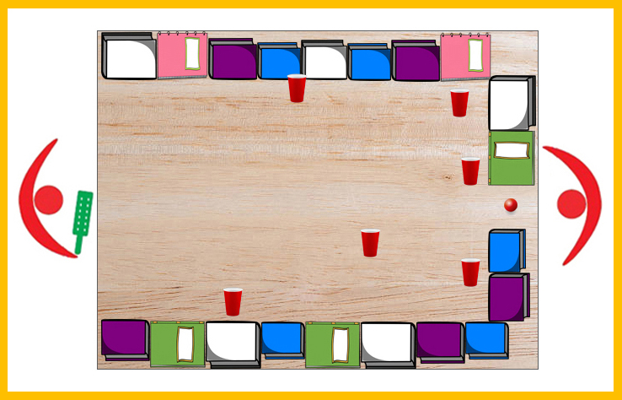
- After every 6 batting hits (one ‘Over’), the bowling team can choose to move their remaining targets, if they wish.
Hit The Gaps

Additional Equipment: Household Items (can be paper cups from previous game)
Set up: Place a household item on every other book around the table (see the grey tin cans on the books, in the below image. I have numbered the gaps, in between the books with the tin cans on, for illustration purposes only). I have 10 gaps. The number of gaps will depend on the size of your table & the size of the books used.

Aim: “Hit the ball into the gaps clockwise around the table.”
- 2 player game. 1 as the bowler. 1 as the batter.
- The ‘Fielders’ are the books with the household items on.
- Bowling:
  - Push the ball slowly towards the batter.
  - The ball is bowled again if the ball bowled is outside the batter’s reach or hits the sides first before reaching the batter.
- Batting:
  - Number of Hits: Allow for 2 more hits than there are gaps. In my example of 10 gaps, allow for 12 balls to be bowled per turn.
  - Batters aim for the gaps in-between the fielders (books), in a clockwise order. In my example, from 1 to 10.
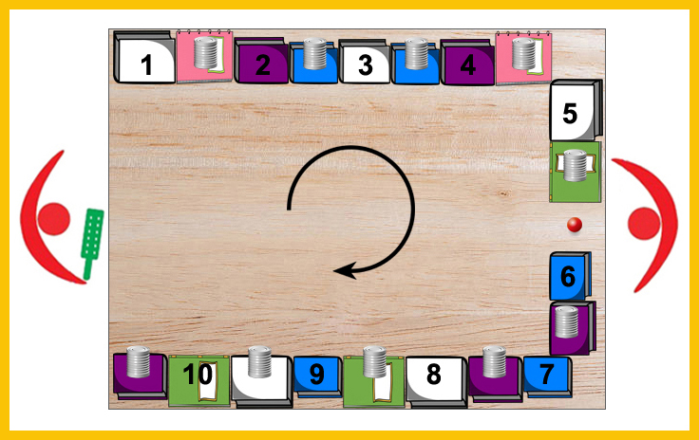
Scoring:
- 1 run (point) for every gap hit in the correct order.
- Only aim for the next gap once the previous has been hit.
- In my example, if the batter gets to the fifth gap and hits it with the final (12th) delivery, the score is 5 runs.
- High Score: Record a ‘Personal Best’ score from a set amount of hits (which is 2 more hits than there are gaps).
- Competition: Have a set amount of hits each, bowling & batting against each other.

Variations:
- To make batting easier allow the hitting of a stationary ball.
- Continuation Version: Continue your next turn from where you finished your last turn. For example, if you finish your last turn aiming for gap 5, start the next turn aiming at this same gap. How many hits does it take for a player to go ‘round the table’ to hit all the gaps in order?
- Change Direction: Start by aiming for last gap (10th) and rotate around the table in the other direction.
- Hit gaps, in any order: To help remember which gaps have been hit, remove the book, or turn it round, or put something on top of it. Play either how many you score from a set amount of hits or how many strikes it takes to hit all the gaps.
- Switch Hit: Batters can hit the gaps in any order. However, they must alternate off-side then on-side shots, for the duration of their batting turn. Alternate gaps 1 to 5, then gaps 6 to 10.
- Round The Table: Batter aims to hit the first gap. If they miss, no runs are scored. The next shot the target moves on to the second gap. If they miss, no runs are scored. The next shot the target moves on to the third gap. Continue. Count the number of times you hit the correct gap.
- The bowler designates which gap the batter has to aim for next.
20/20 Cricket Match
Additional Equipment: Run Tabs - Numbers on paper (Print out included), 5 x Household Items (Tin Cans)

Aim: “Cricket Match with 20 balls each!”
- 2 player game. 1 as the bowler. 1 as the batter. If you have more players, create teams.
- Decide who will bat first.
- Bowlers place their fielders (5 x Household items) on books around the table sides in any position. If the batter hits the ball onto the books with the items on they are out “Caught”.
- Bowlers place the printed ‘run tabs’ on top of any vacant books. You have 1 run, 2 run, 4 run, 6 run tabs. See print out at end of this document. The bowler need not use all of the run tabs. You can have some books with no run tabs on them, ‘0 Runs’. Use the same set of run tabs for both innings (players turns). See diagram as an example of fielder & run tab placing.
- Bowling:
  - Push the ball slowly towards the batter.
  - The ball is bowled again, if the ball is bowled outside the batter’s reach or hits the sides before reaching the batter.
- Batting:
  - Receive 20 balls.
  - Aim to hit the ball against the book sides with the run tabs on.
- After the batter has received 20 balls. Swap roles. The Batter becomes the Bowler. The Bowler can re-arrange the field (household items) & the same set of run tabs in any position.
- In the below example, there are 5 fielders (Tin Cans), 4 x 1 runs, 2 x 2 runs, 2 x 4 runs, 2 x 6 runs on the books, and, 4 x 0 runs blank books.
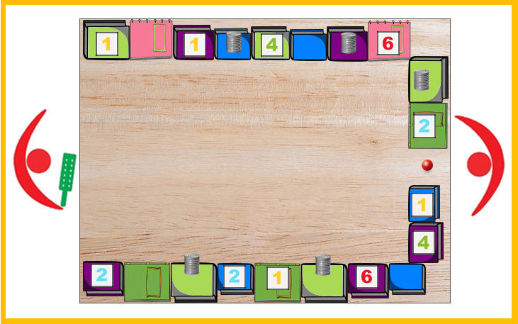
Scoring:
- First contact of the ball against the book sides is the outcome.
- 0 Runs - Books with nothing on.
- 1, 2, 4, 6 runs – Books with the run tabs on them.
- Out Caught – Books with fielders (household item) on them. Out Caught is Minus 5 runs!!

Variations:
- To make it easier,
  - The ball hitting a book with a household item on is “Fielded” (0 Runs), rather than “Out caught” (Minus 5 runs)
  - Batters hit a stationary ball.
  - Fielder & Run Tabs positons are the same for both players.
- To make it more difficult,
  - You are only allowed to lose 3 wickets (3 “Outs!” and your batting turn finishes).
- To make “Out caught!” more fun add a random “Dropped Catch” rule. Perhaps use a dice, 5/6 is a dropped catch. Or flip a coin, tails is a drop, not out! 0 runs instead.
- Add other ways to get “Out!”, including:
  - Bowled - The batter misses the ball and it drops off the end of the table.
  - LBW - The ball hits the batter’s body, including their hand.
- After 10 balls bowled, the bowling team can choose to move any fielders or run tabs.
- Super Over Game - Change number of balls received. Batters receive 6 balls each. Highest score wins.
Scoring Templates Players Name ______________________
Solo & Collaborative Games
Game Played: | Attempt 1 | Attempt 2 | Attempt 3 | Attempt 4

Competitive Games
Players Name | Scores |  | Players Name

Example  Ella |  |  | Grandpa
Email: events@panathlon.com Twitter/Instagram/Facebook: @panathlon #PanathlonIndoorGames
Run Tabs for ‘20/20 Cricket Match’ (To Print / Cut out)
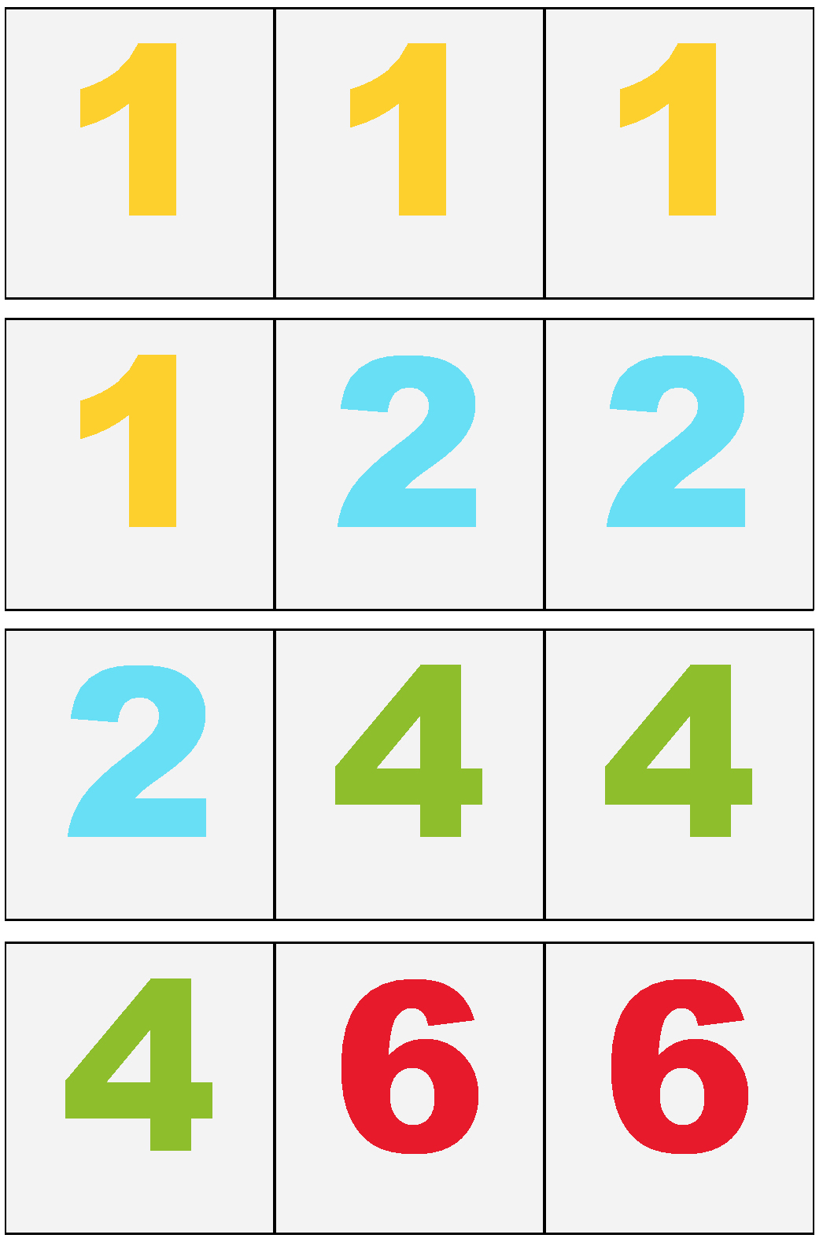
20/20 Cricket Match
Batter’s Name: | Ball 1 | Ball 2 | Ball 3 | Ball 4 | Ball 5 | Ball 6 | Ball 7 | Ball 8 | Ball 9 | Ball 10 | Ball 11
 | Ball 12 | Ball 13 | Ball 14 | Ball 15 | Ball 16 | Ball 17 | Ball 18 | Ball 19 | Ball 20 | Overall Score

Batter’s Name: | Ball 1 | Ball 2 | Ball 3 | Ball 4 | Ball 5 | Ball 6 | Ball 7 | Ball 8 | Ball 9 | Ball 10 | Ball 11
 | Ball 12 | Ball 13 | Ball 14 | Ball 15 | Ball 16 | Ball 17 | Ball 18 | Ball 19 | Ball 20 | Overall Score

Batter’s Name: | Ball 1 | Ball 2 | Ball 3 | Ball 4 | Ball 5 | Ball 6 | Ball 7 | Ball 8 | Ball 9 | Ball 10 | Ball 11
 | Ball 12 | Ball 13 | Ball 14 | Ball 15 | Ball 16 | Ball 17 | Ball 18 | Ball 19 | Ball 20 | Overall Score

Batter’s Name: | Ball 1 | Ball 2 | Ball 3 | Ball 4 | Ball 5 | Ball 6 | Ball 7 | Ball 8 | Ball 9 | Ball 10 | Ball 11
 | Ball 12 | Ball 13 | Ball 14 | Ball 15 | Ball 16 | Ball 17 | Ball 18 | Ball 19 | Ball 20 | Overall Score
Email: events@panathlon.com Twitter/Instagram/Facebook: @panathlon #PanathlonIndoorGames

